Flask and MongoDB Assignment
Task 1: JSON API Route
Explanation
For this task, I created a Flask application with an /api route.
The data is stored separately in a file named data.json. When the /api route is opened, the Flask application reads the data from data.json using Python's json module.
The data is then returned as a JSON response using Flask's jsonify() function.
This keeps the data separate from the main Python file and allows the API to read the data from the backend file.

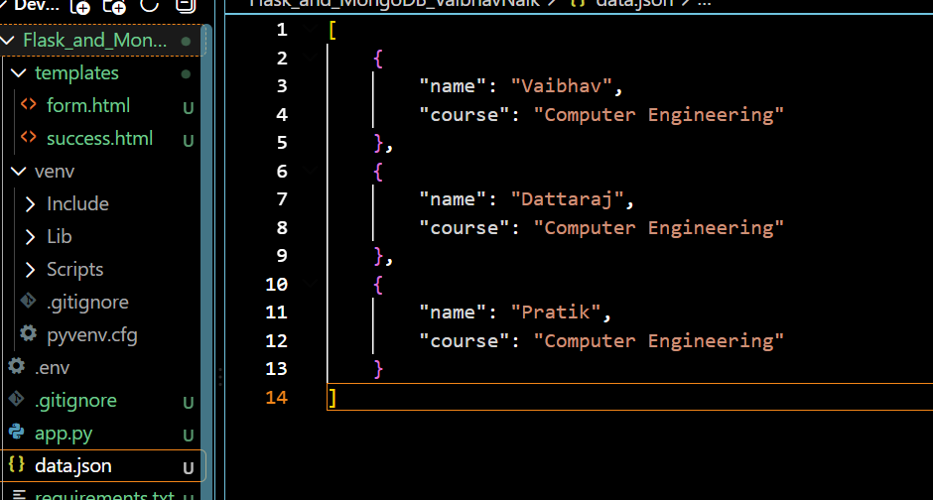

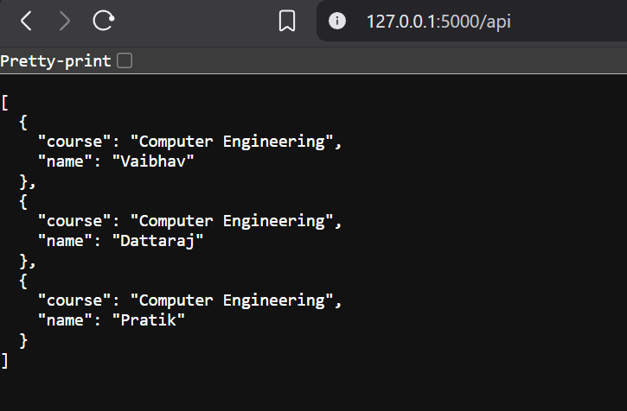

Task 2: Frontend Form with MongoDB Atlas
Explanation
For this task, I created a student registration form with three fields:
- Name
- Email
- Course
When the user fills in the form and clicks the Submit button, the data is sent to the Flask application.
The Flask application receives the form data and inserts it into the students collection inside MongoDB Atlas.

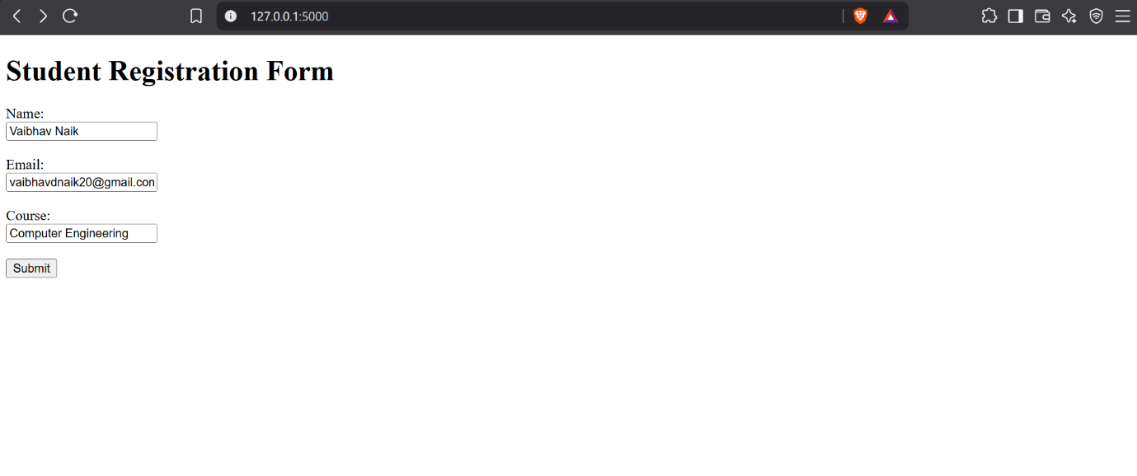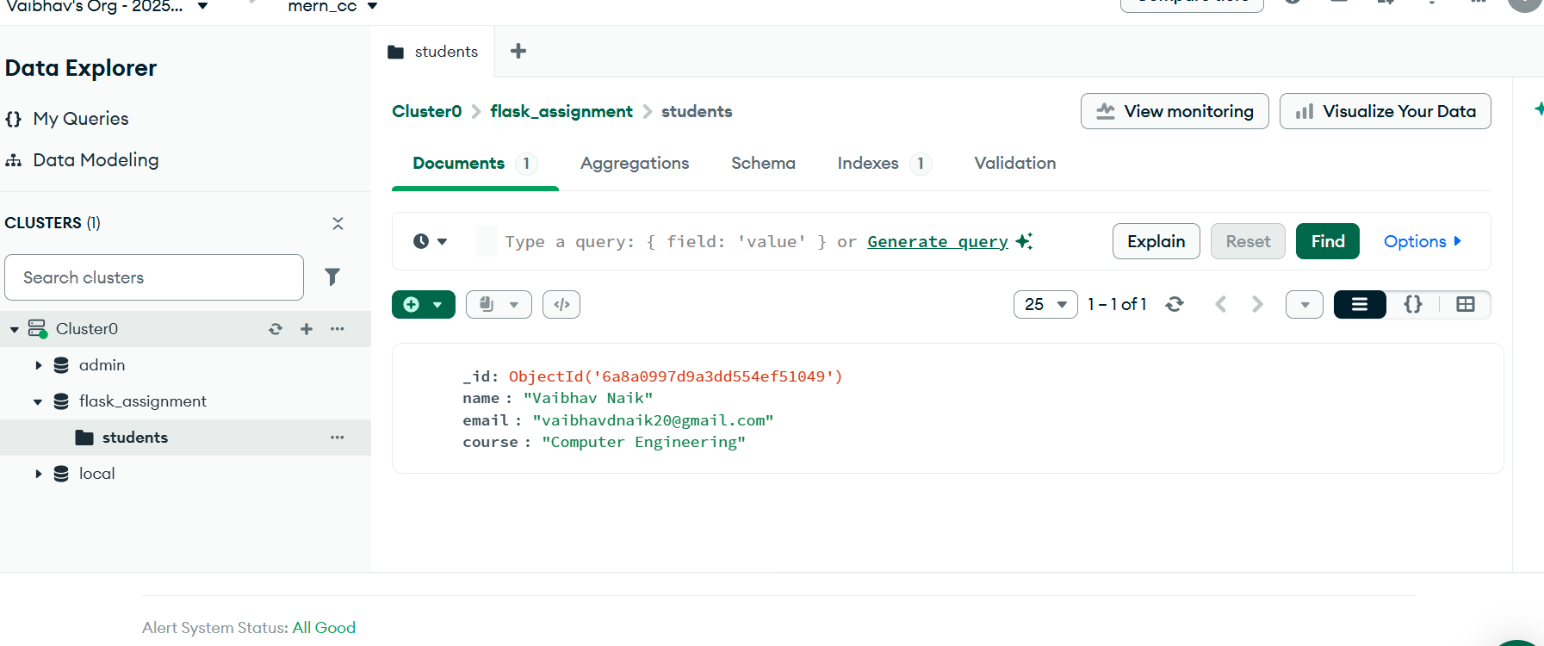

- Successful Submission
Explanation
After the data is successfully inserted into MongoDB Atlas, the Flask application redirects the user to the /success page.
The success page displays the message:
Data submitted successfully
This confirms that the form data was successfully stored in MongoDB Atlas.
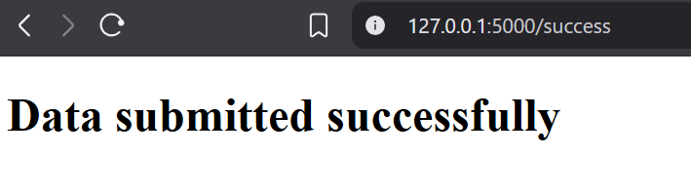

- Error Handling
Explanation
I also added error handling to the form.
If there is an error while submitting the data, Flask catches the error and displays the error message on the same registration form page.
The user is not redirected to the success page when an error occurs.

